Concat: sample data

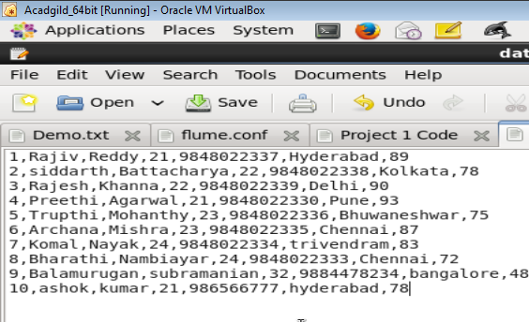

Loaded the sample data into HDFS location under /user/acadgild/pig/dataset1



Viewing the data of Relation A



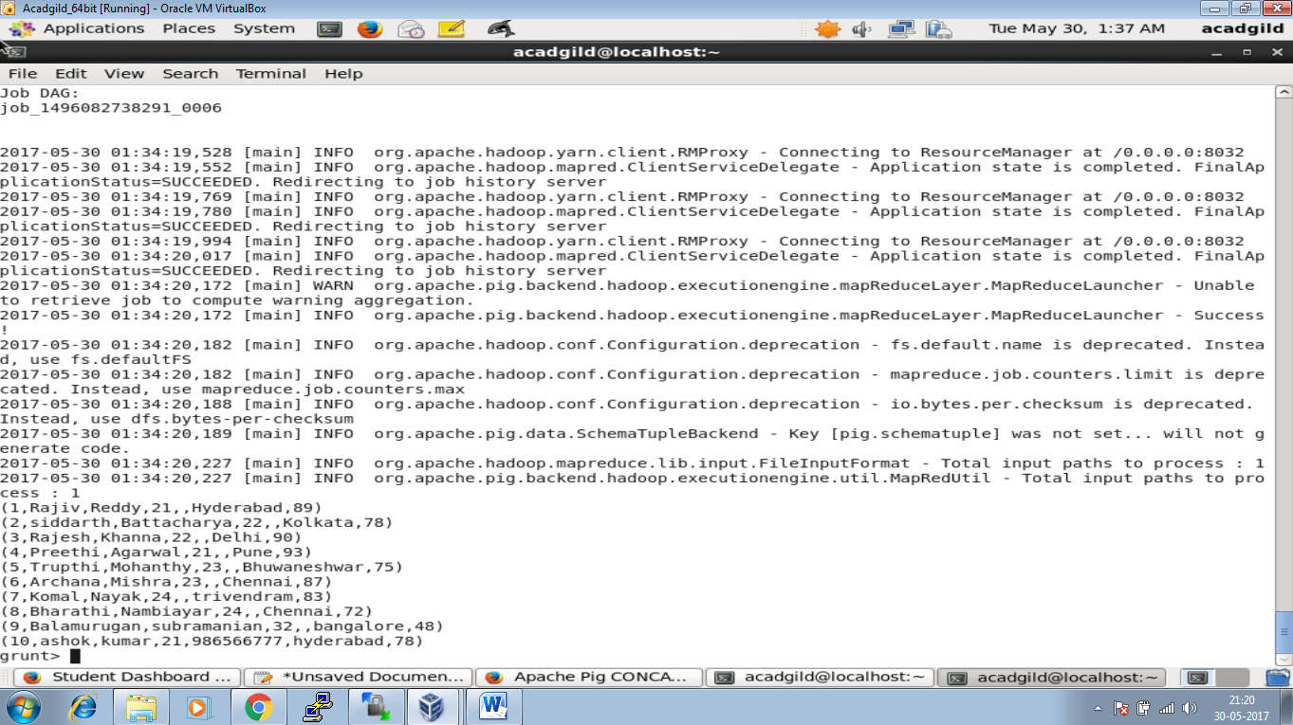

Now issued a command in console for concatenating the firstname and lastname



Viewing the concatenated data by dump command



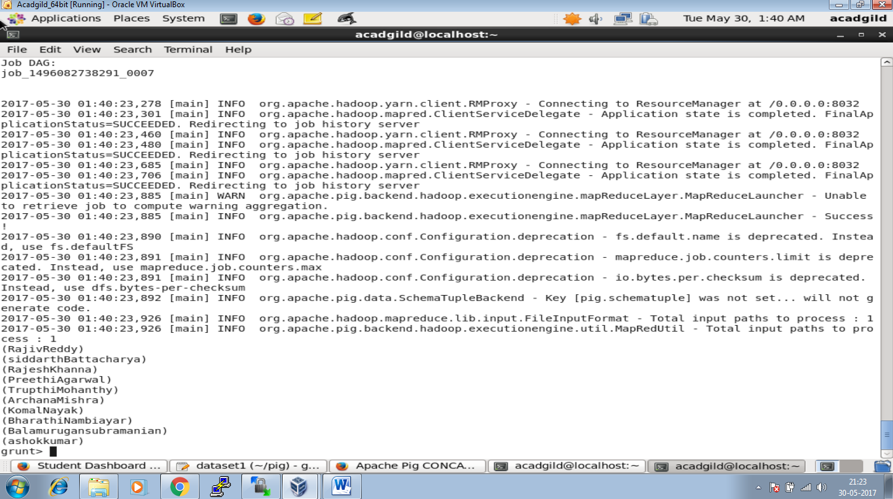

Code for concat using pig

